Welcome to Pro Tax Solvers

Your Trusted Partner for Tax Resolution and Financial Expertise

Solving Your Tax Challenges, Empowering Your Finances
At Pro Tax Solvers, we bring over 30 years of experience in providing exceptional tax resolution, audit, accounting & bookkeeping services, and business advisory. Based in Las Vegas, Nevada, we proudly assist clients nationwide. Our unwavering commitment is to focus solely on helping individuals and businesses overcome back-due tax debts and related financial challenges.

Why Choose Us?
- Expertise: Our seasoned team specializes in tax resolution, accounting, and bookkeeping, ensuring top-tier service delivery.
- Proven Success: We consistently achieve outstanding results, earning a reputation as leaders in the industry.
- Comprehensive Offerings: Whether you're wrestling with tax debts, seeking CFO services for your small business, or in need of meticulous accounting and bookkeeping, we offer comprehensive solutions.
- Fair Pricing: Our transparent fee structure ensures fairness, with charges based on the work required for your specific case.
- Accessible Support: We guarantee easy access to your attorney for any questions or concerns about your case.

Our Commitment
Our commitment to you is clear: we provide realistic assessments and explore every legal avenue to secure the best possible outcome for our clients. We understand that one size doesn't fit all, and our fee structure is designed to be fair, avoiding hefty flat fees.

Get in Touch Today
Ready to regain control of your financial situation and find lasting solutions to your tax challenges? We're here to assist. Reach us at (702) 360-0952, schedule a consultation with a tax advisor, or use our live chat function for immediate assistance.

Contact Information
Pro Tax Solvers
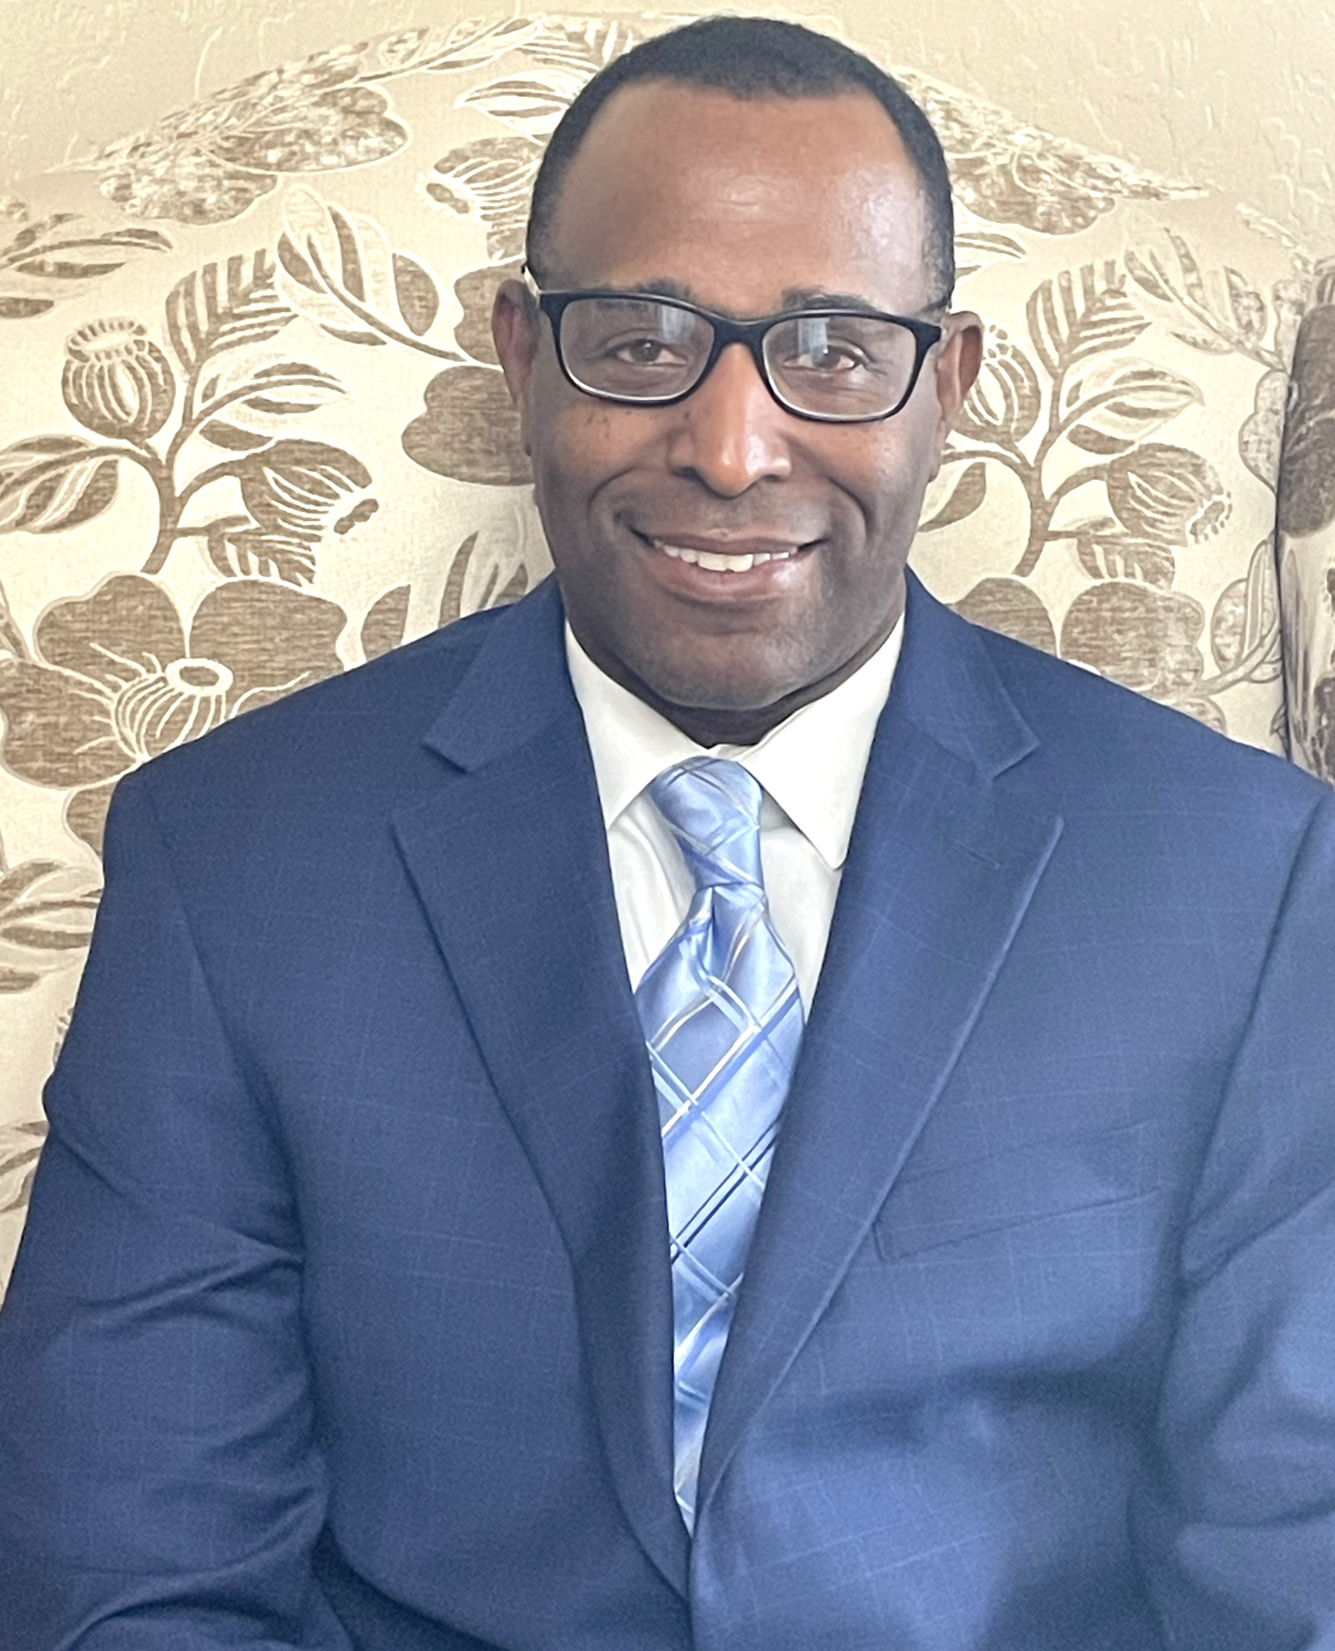
Henry Thomas, CEO
Enrolled Agent

- Address: 3301 W. Spring Mountain Road, Suite 17, Las Vegas, NV 89102
- Phone: (702) 381-2425
- Fax: (702) 935-9116
- Email: support@protaxsolvers.com

Partner with us on your journey to financial clarity and peace of mind.

